# Report for final project

A typical kernel mode program should look like this:

For this test c program, it will call the start function when OS load the module by using “insmod test.ko” and it will call the end function when unload the module by using “rmmod test.ko”

So, based on this, we could use the same structure to code our block demo like this:

Call the init and exit function at the bottom of the code:



In init function, we should

* register new block device and get device major number
* set some random capacity of the device
* allocate corresponding data buffer
* set required flags and data
* init the device name
* notify kernel about new device

In the exit function, we should

* delete generated disk
* cleanup the queue
* free the allocated space
* unregister device

My make file like this:

It can compile success under kernel 5.X:

After compile, it will generate a ko file:

Using insmod to load the model:

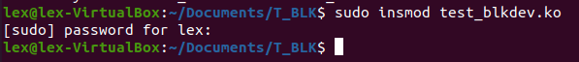

List models:

Assign the disk file type:

Mount the test block:



The disk mounted successfully:

Finally, unmount the disk, remove model from kernel and verify by listing models with ‘test’:

